Machine Learning for Customer Complaint Categorization.

CIS4143 Machine Learning & Big Data
Tanveer Hussain
Kate Forshaw
25259628

Word count: 3540

Contents
Abstract ………………………………………………………………………………………3
Introduction ………………………………………………………………………………….4
Literature Review ……………………………………………………………………6
Methodology …………………………………………………………………………………8
Data Collection ………………………………………………………………………8
Preprocessing ………………………………………………………………………...8
Machine Learning …………………………………………………………………...9
Evaluation Materials ……………………………………………………………….10
Results ……………………………………………………………………………………….11
Visualisation ………………………………………………………………………...11
Analysis ……………………………………………………………………………..14
Discussion …………………………………………………………………………………...16
Comparison …………………………………………………………………………16
Conclusion …………………………………………………………………………..18
References …………………………………………………………………………………..20
Appendices ………………………………………………………………………………….26

Abstract
Companies like Amazon utilise customer complaints to resolve their issues and improve their all-round productivity. It is important that complaints are categorised correctly, so the appropriate form of action can be followed in pursuit of them. The speed and volume in which complaints are generated in today’s society, a more efficient method of complaint categorization is required. In this study, three machine learning models were trained on 200 Amazon customer complaints and tested to accurately predict the contents of a complaint. the models Logistic Regression, Linear SVM, and Naïve Bayes were chosen to determine whether a complaint was regarding customer service, delivery, payment/billing, product quality, or technical website/app. These models were evaluated based on confusion matrix, precision, recall, F1-score, and accuracy. The results indicated that Logistic Regression and Linear SVM outperformed Naïve Bayes with accuracy rates of 80% compared to 75% - though these were all relatively successful rates. However, all three models were insufficient at identifying the complaint category payment/billing, with a precision of 0.6 (Naïve Bayes) and recalls of 0.5 (Logistic Regression & Linear SVM) and 0.38 (Naïve Bayes). To account for these significant misclassifications, improvements in the dataset and/or models is necessary. It was suggested to increase the population of the dataset and adopt an adaptive boosting method to create one stronger model made up of the fairly strong models present. This would be dependent on whether a company like Amazon desire a short-term or long-term fix to enhance them.

Machine Learning for Customer Complaint Categorization
The intention of feedback is to identify strengths, abilities, and areas that are in need of development (Chur-Hansen & Mclean, 2006). Although less desired than positive feedback (Audia & Locke, 2003), negative feedback, also known as criticism or a complaint, can be considered a judgement of high importance, which broadens the understanding of an outsider (Sardar & Anwar, 2021). A customer complaint is a type of criticism that assesses a consumer’s dissatisfaction with a service or product (Forbes, 2008). This can encourage a path of research into advancing the particular service or product, utilizing and implementing the customer’s interpretation to maximise the whole improvement process (Bulsara & Thakkar, 2016).
Businesses are faced with large volumes of complaints. It differs significantly between industries, but in the metrics for general business the average complaint rate, and the point in which action should be taken, is approximately 5-10% (KPI Depot, 2025). How a business tackles these complaints will establish its success (Herman, 1983), though many challenges will be encountered throughout the process. Manually sorting customer complaints is a form of incompetency which is time-consuming and error-prone, leading to difficulty in gaining real-time observations accurately (Lauzier, 2022). Additionally, it is labour-intensive, indicating manual handling hinders resources and deflects them to the tasks of less value - organising customer complaints - burdening the productivity of the business.
The problem that is being addressed in this paper is the battle to classify customer complaints into relevant categories efficiently for timely resolution and analysis. This problem has an impact on misclassification, signifying when complaints are incorrectly categorized (Fox et al., 2022), it initiates a ripple effect over customer service and business operations. This concerns complaints being sent to the wrong department, therefore needing to be redirected and delaying the issue being resolved (Wainscott, 2024). Following this, a customer may feel undervalued or ignored if their issue is not dealt with in a timely honour due to it being misconceived and misplaced (Hutchinson, 2011), resulting in more negative reviews potentially being contrived. The misclassification also induces the distribution of workload to be distorted as time is wasted tackling complaints that are not within someone’s expertise (Caldeira, 2022). Furthermore, it skews the perceptions into product and service issues, ensuing inadequate strategies and opportunities for improvements being strayed (Korvola, 2021). In a worst-case scenario, a misclassification of a complaint can lead to a penalty as a complaint of legally sensitivity or high priority could be deferred (Weil & Pyles, 2005).
Customer complaint categorization is relevant in today’s world due to the drastic inflation in digital platforms. The rate at which the global digital platform market is rising from 2025-2030 is 10.3% (Meravath, 2025). Digital platforms facilitate the communication between businesses and consumers (Bayir & Bozyigit, 2024), implying as the use of digital platforms increases, as does the surge of complaint data. This requires for an organisation system to attain automation through machine learning and natural language processing (NLP) techniques. The real-world scenario this project will be applying machine learning to is categorizing the complaints of Amazon customers.
Amazon is the greatest online retailer in the world and one of the biggest suppliers of cloud services (Awati & Yasar, 2025). This project aims to unveil and collect as much of their customer complaints as possible and develop a machine learning model to categorize these complaints into predefined classes, which should help Amazon to identify and resolve their areas of improvement. Detailed in this report will be previous studies that have addressed similar problems; the characteristics of the dataset; any preprocessing steps taken; the machine learning model selection; the metrics used to evaluate the model; the visualisation of the results; the analysis of the results; and the conclusion regarding the main findings of the project.
Literature Review
Aris-Brosou et al. (2018) aimed to predict customer complaints based upon quality control (QC) data obtained by vitro diagnostic systems, to reduce the number of customer complaints. Five vitro diagnostic assays – medical devices that examine human body samples to detect disease, conditions, and infections (World Health Organization, 2025) – were linked to databases of customer complaints, over 90 days and 45 days periods, that corresponded. One of the machine learning algorithms was established on adaptive boosting and the other decision trees. The cross-validations used to assess model performance presented adaptive boosting to have error rates close to zero, and performance accuracy was enhanced over the shorter period of days. This suggests adaptive boosting as a machine learning model can be utilized for the prediction of complaints regarding quality control from customers.
Alarifi et al. (2023) desired to analyse and predict customer complaints of general products through machine learning. The techniques used were logistic regression and support-vector machine (SVM) and they downloaded five datasets with varied time frames: 1 month, 3 months, 6 months, 1 year, and 3 years, while listing the number of complaints for each of the datasets. Their findings indicated that both logistic regression and SVM had the ability to accurately predict customer complaints, however SVM provided the most success with its predictions.
Choi (2018) assembled machine learning algorithms to anticipate customer complaints in the mobile telecom industry. There were four machine learning algorithms used, Artificial neural networks (ANN), support vector machine (SVM), k-nearest neighbours (KNN), and decision tree (DT), with a database consisting of 10,000 Korean mobile market subscribers and their complaint status. It was found that the algorithm with the greatest performance in complaint prediction was ANN. Moreover, the results of the segmented-prediction model inferred that the prediction power was superior for the non-iPhone users, females, and older customers.
Khedkar and Shinde (2020) intended to classify online hotel customer reviews as a praise or a complaint through machine learning, to determine a customer’s reason for their satisfaction or dissatisfaction. They propose a machine learning and deep learning-based approach to distinguish a praise or complaint, incorporating dense neural network and CNN to train a vital set of words such as verbs, nouns, intensifiers, and adjectives present in the review. Their findings demonstrated that this method of deep learning can successfully classify whether a customer review on a hotel was positive or negative (praise or complaint) and had more promising F1-scores in contrast to previous advanced classifiers.
Bozyigit et al. (2022) used machine learning methods for the categorization of customer complaints in the food industry. Obtained from a Turkish food supplier, their dataset recorded five different categories of issues: ‘unhygienic’, ‘foreign body’, ‘texture’, ‘package/label’, and ‘taste/smell’. This dataset was analysed using logistic regression (LR), naïve bayes (NB), k-nearest neighbour (kNN), support vector machine (SVM), random forest (RF), and extreme gradient boosting (XGBoost). They found that the most successful method was XGBoost, achieving an F-measure score of 84%. This indicates that this machine learning approach attained a high mean of precision and recall for customer food complaint categories.

Methodology
Data Collection
The dataset used was called ‘complaint categories dataset’, which was created by the author of this report. It was a small dataset containing 200 Amazon 1-star reviews, all of which were assigned an issue type. There were five categories of complaints: delivery, payment/billing, customer service, product quality, and technical website/app. Delivery issues concerned late delivery, lost packages, or wrong delivery address; product quality problems were defective items, damaged goods, or incorrect product; payment/billing issues included overcharging, incorrect billing, or refund delays; customer service complaints involved poor support experience, rude staff, or long wait times; and technical website/app issues were problems with app functionality, login errors, or checkout failures. The data was collected from Amazon reviews on Trust Pilot, where 65% of the reviews were rated 1-star (Trust Pilot, 2025).
Preprocessing
To begin the preprocessing, the required packages were imported in (see appendix 1), and the complaint categories dataset was uploaded (see appendix 2).
A step was taken to clean the labels and normalise the categories, which consisted of normalizing casing, trimming whitespace, and fixing obvious typos (see appendix 3). The text labels were converted to numeric labels as machine learning models can only understand numbers (Howell, 2025). The issue types were sorted alphabetically, and each assigned an integer, this was presented in a dictionary that was created (see appendix 4). Customer service was assigned 0, delivery 1, payment/billing 2, product quality 3, and technical website/app 4.
Next was the normalisation process and cleaning of the text (comments). The aim was to reduce words to their root through normalizing lowercase and whitespace and removing stray quotes and special symbols, except from apostrophes and slashes (see appendix 5). Common typos within the text were handled and corrected (see appendix 6).
Class distribution was checked to see if there was an imbalance of issue types after the cleaning process. A table of counts for each class was written out and demonstrated them as all remaining equal at 40 (see appendix 7).
Feature engineering took place, which is where the cleaned text was converted into numerical features that machine learning models can comprehend (Zheng & Cassari, 2018). The data was split into training and testing sets (see appendix 8) as the model learns from the training data, and it is evaluated based on the unseen test data. This determined which text got vectorized and learned from. TF-IDF vectorization also was a part of this process. Each complaint was transformed into a numerical vector based on how often a word appeared in a complaint, and how rare that word was across all complaints (see appendix 9).
The label encoder and vectorizer artifacts were saved for reuse (see appendix 10).
Machine Learning
There were three machine learning models trained: Logistic Regression, Linear SVM, and Naïve Bayes (see appendix 11). The complaints categories dataset is text-based, has multiple classes, and is small. This highlights that there are not enough rows of data for deep learning, but natural language processing (NLP) models, like the ones acquired, can produce highly accurate results, while being trained with very little data (Rao et al., 2018). Logistic Regression is a vigorous and effective method, more so than complex models, for interpreting small groups of data (Stoltzfus, 2011). Linear SVM can decipher marginal differences between categories (Fu et al., 2010). Naïve Bayes can attain classification through capturing word patterns and asymmetries (Hovold, 2005).
Both Logistic Regression and Liner SVM were specified a balanced class weight to fix potential class imbalance, but Naïve Bayes does not support class weight as it naturally handles imbalance sufficiently. Control for imbalance is crucial, especially for small, under sampled datasets, as several models are more likely to predict the most populated class, rather than the one with the most association (Buda et al., 2018).
Evaluation Materials
A confusion matrix assisted the evaluation through the comparison of predicted values and real values for the dataset (Murel & Kavlakoglu, 2025) (see appendix 12). It uses a method of visualisation – a table – for the results.
Precision was obtained to measure how many accurate positive predictions the models had made; recall tested the number of precisely identified positive cases by the model; and F1 score as a combination of precision and recall (Geeks for Geeks, 2020). F1 score can be represented as an equation: 2 * ((precision * recall) / (precision + recall)).
Accuracy, which was utilised for assessing the classification models’ performances (Geeks for Geeks, 2020b), was accounted for. The equation for this is (number of correct predictions) / (total number of predictions). This is essential for the comparisons between the different models.

Results
Visualisation
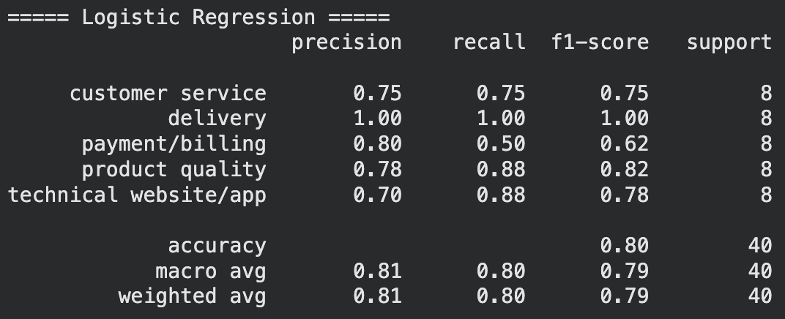
Figure 1 Evaluation of Logistic Regression table
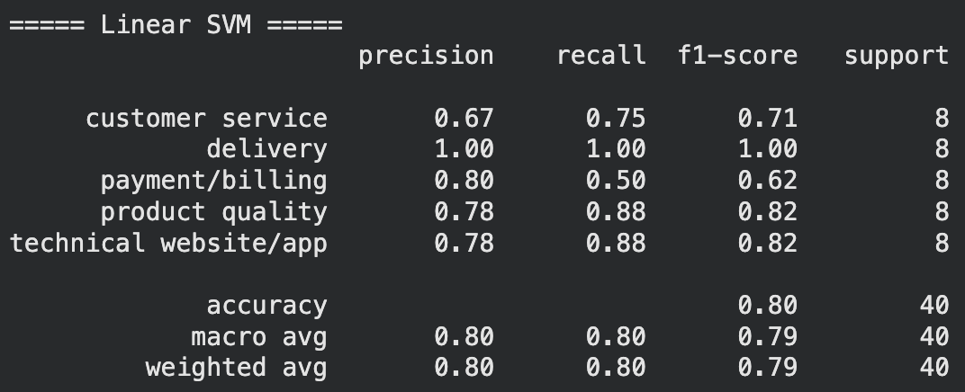
Figure 2 Evaluation of Linear SVM table
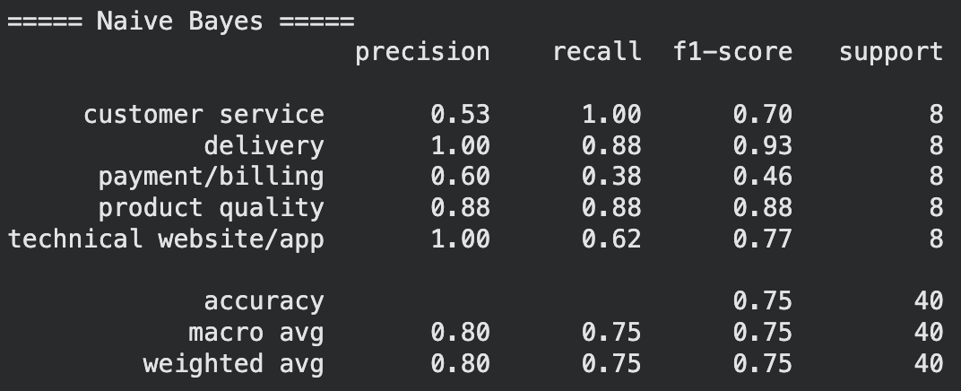
Figure 3 Evaluation of Naïve Bayes table
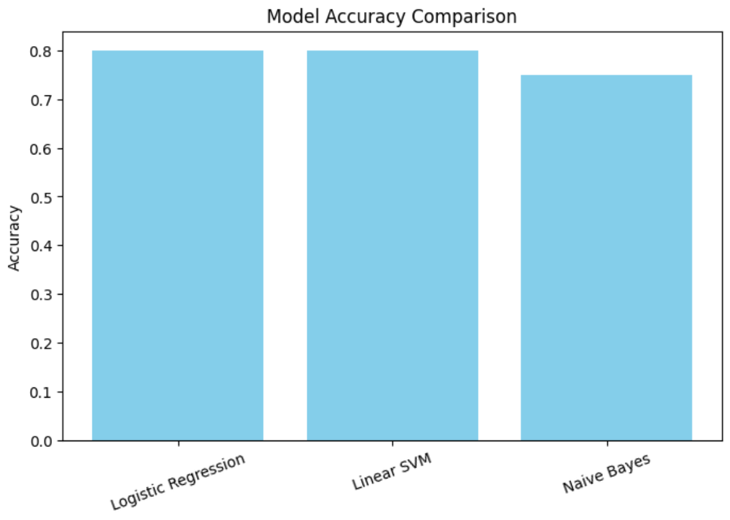
Figure 4 Bar chart of model accuracy comparison
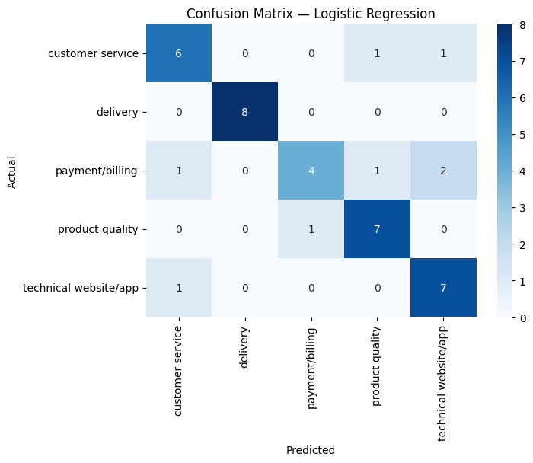
Figure 5 Heatmap of confusion matrix for Logistic Regression
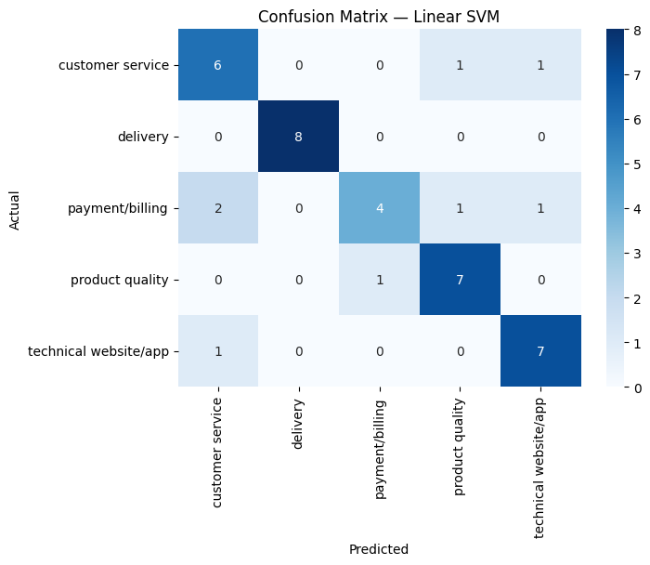
Figure 6 Heatmap of confusion matrix for Linear SVM
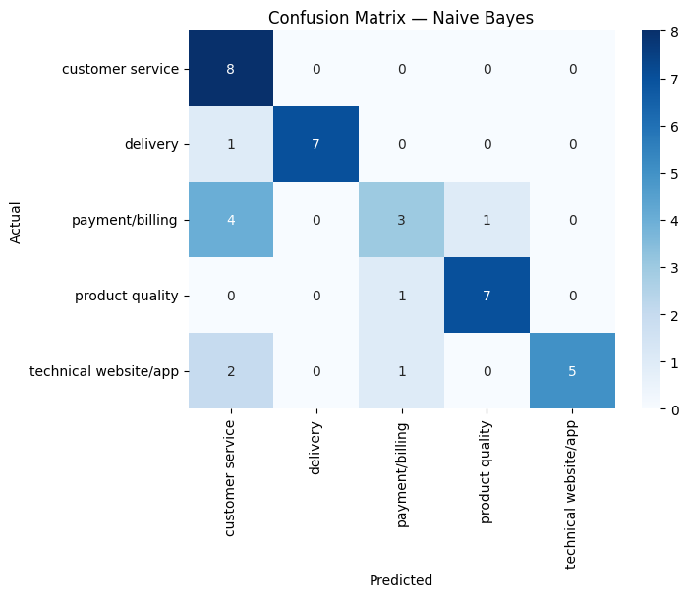
Figure 7 Heatmap of confusion matrix for Naïve Bayes
Analysis
Logistic Regression had an F1-score of 0.75 for the category customer service, 0.82 for product quality, and 0.78 for technical website/app (see figure 1). This indicates it was fairly strong in accurately identifying complaints regarding low quality items, technical issues, and insufficient customer care. The F1-score for delivery was 1 which implies that the precision and recall of Logistic Regression was perfect when categorizing delivery problem complaints. The model produces an imbalance for the category payment/billing, with a precision of 0.8 and recall of 0.5. This highlights that when it predicted a positive, it was correct a lot of the time (80%), but it only found half of the actual positive cases for complaints concerning wrongful payments. Furthermore, the confusion matrix heatmap of Logistic Regression demonstrates that the model was accurately predicting all the complaint categories frequently, except from payment/billing (see figure 5). There were only moderate accurate predictions for the category, and this type of complaint was sometimes confused with customer service, product quality, or technical website/app. Additionally, a customer service complaint could be misinterpreted for product quality or technical website/app, product quality complaint for payment/billing, and technical website/app complaint for customer service.
Linear SVM achieved similar (if not the same) F1-scores: customer service was 0.71, delivery was 1, payment/billing was 0.62, and both product quality and technical website/app were 0.82 (see figure 2). This infers Linear SVM was also fairly strong in identifying low quality items, technical issues, and insufficient customer care complaints correctly. Moreover, the model lacked half of the positive cases for wrongful payment complaints, however, was always correct and precise when predicting complaints about delivery problems. The confusion matrix heatmap of Linear SVM was almost identical to the one for logistic regression. It highlighted that the model could accurately predict customer service, delivery, product quality, and technical website/app often (see figure 6). However, it misclassified payment/billing with customer service slightly more frequently than technical website/app, compared to the Logistic Regression model which confused it with technical website/app more often.
Naïve Bayes attained lower F1-scores for most of the categories: 0.7 for customer service, 0.93 for delivery, 0.46 for payment/billing, and 0.77 for technical website/app (see figure 3). This may be due to the significant variations between precision and recall. Naïve Bayes correctly identified every actual positive case for customer service (recall = 1), but only 53% of the model’s positive predictions were correct. The model could correctly predict delivery 100% of the time but finds a few false negatives (recall = 0.88). Sixty percent of the model’s positive predictions for payment/billing were accurate, but it failed to detect a large portion of true positives (recall = 0.38). The model could accurately predict technical website/app 100% of the time but identifies some false negatives (recall = 0.77). For product quality, Naïve Bayes shows a slight improvement in its F1-score with 0.88, suggesting it was relatively strong in identifying complaints about low quality items. The confusion matrix heatmap of Naïve Bayes highlights the model could accurately predict customer service, delivery and product quality frequently (see figure 7). Payment/billing was misclassified as customer service more often than predicted as itself. The model could confuse technical website/app with payment/billing as well as customer service and it had also confused delivery with customer service.
A comparison between the accuracy of each machine learning model was illustrated on a bar chart (see figure 4). The chart indicated that Naïve Bayes had a lower accuracy than Logistic Regression and Linear SVM – 0.75 compared to 0.8. This implies that the Logistic Regression and Linear SVM models were more accurate at predicting the categories of customer complaints.
Discussion
Comparison
The results of this unique dataset will be compared against previous research in the field based upon similar categorized data.
A customer complaint dataset was acquired to predict specific quality issues of a product (Aris-Brosou et al., 2018). The machine learning model Adaptive Boosting almost achieved 100% accuracy in its identifications of product quality complaints. Adaptive boosting enhances the precision of predictors through the combination of multiple weak models, essentially creating one strong model (Subasi, 2020). Although, high accuracy scores of 80 and 75 were attained by the models in this study, they all lacked in identifying payment/billing complaints and they each got them confused with varied numbers of other complaints. This misclassification could have been improved by combining these models together via adaptive boosting, to cancel out each models’ errors. Therefore, the accuracy score may have risen closer to 100%.
Five datasets – with different time frames – concerning customer complaints on products desired to be analysed and predicted with Logistic Regression and SVM (Alarifi et al., 2023). The SVM model marginally outperformed Logistic Regression with F1-scores ranging from 0.84 – 0.89, and accuracy rates of 84% – 90%. This also outperformed the Logistic Regression and Linear SVM models in this research. This may be due to it containing complaints from random time points, whereas the previous study acquires datasets with specified time frames. Their greatest F1-score and accuracy was achieved from the shortest time frame of 1 month. This suggests that models can correctly identify more complaints within a shorter time frame, implying that the data collected for this dataset potentially should have been complaints over a short period of time, rather than anytime in the past years.
Ten thousand customers and their complaint status made up a dataset which was used to anticipate a complaint based upon customer characteristics and previous complaints (Choi, 2018). The machine learning models in use were ANN, SVM, KNN, and DT, the accuracy rates of which were approximately 80%, 72%, 79%, and 63%. Their SVM model was outperformed by the Linear SVM model in this study (80%), inferring its predictions are less accurate when learning with a larger dataset and when more complex predictions are involved. This accentuates that Linear SVM was one of the most efficient models to select for categorization of a small number of customer complaints in this research.
A dataset of customer reviews, which could be positive or negative, were collected for deep learning to classify them as a praise or a complaint (Khedkar and Shinde, 2020). Deep learning models demand greater numbers of data to enhance accuracy (IBM Data & AI Team, 2025). Though unable to access the actual numbers, Neural Network and CNN were stated to have attained more promising accuracy and F1-scores in comparison to efficiently trained models. This implies that a lot more data should have been collected in this study to obtain more profound models that may be able to correctly classify the category of a customer complaint, more so than the NLP models trained.
Customer complaint categorization with machine learning was applied to a dataset of customer issues with food split into five categories (Bozyigit et al., 2022). Six different models were trained, one of which was Naïve Bayes, achieved F1-scores of 0.73, 0.53, and 0.62. However, with F1-scores of 0.83 and 0.84, the best performing model was XGBoost. The Niave Bayes models performed similarly across both studies, signifying this model can only provide moderately correct and accurate identifications of complaint categories. Therefore, XGBoost should perhaps have been acquired to discover whether it would have also outperformed logistic regression and Linear SVM.
Conclusion
Despite the small dataset, Logistic Regression, Linear SVM and Naïve Bayes have been successfully trained to precisely categorize most customer complaints by customer service, delivery, payment/billing, product quality, and technical website/app. If Amazon, or another company in the supplier industry, required identification of their complaint contents, Logistic Regression or Linear SVM would be recommended as they are more accurate predictors, exuding less errors. This would be a short-term fix to keep up with the increasing number of complaints. Though, if they desired to uproot their company and make significant changes to it, they should investigate models that have error rates closer to 0% than at 20% where it currently stands.
For future research, this study should be replicated with at least 200-300 more complaints collected over a small-time frame; another machine learning model should be trained, such as XGBoost; the precision, recall, F1-score, accuracy, and confusion matrix should be tested for each individual model, and the models combined via Adaptive Boosting. This should account for the limitations faced with the dataset being small, the dataset being too broad, only training relatively strong models, and misclassification rates being quite high. This would allow companies to carry out the precise action that would be required in response to a specific complaint category.

References
ALARIFI, G., RAHMAN, M.F. and HOSSAIN, M.S., 2023. Prediction and analysis of customer complaints using machine learning techniques. International Journal of E-Business Research (IJEBR), 19(1), pp.1-25. Available from: 10.4018/IJEBR.319716
ARIS-BROSOU, S., KIM, J., LI, L. and LIU, H., 2018. Predicting the reasons of customer complaints: a first step toward anticipating quality issues of in vitro diagnostics assays with machine learning. JMIR medical informatics, 6(2), p.e9960. Available from: https://medinform.jmir.org/2018/2/e34/
AUDIA, P.G. and LOCKE, E.A., 2003. Benefiting from negative feedback. Human Resource Management Review, 13(4), pp.631-646. Available from: https://doi.org/10.1016/j.hrmr.2003.11.006
AWATI, R. and YASAR, K., 2025. What is Amazon? Definition and company history of Amazon.com. WhatIs [online]. Available from: https://www.techtarget.com/whatis/definition/Amazon
BAYIR, T. and BOZYIGIT, S., 2024. Consumer Complaints Management in the Digital Era. In Digital Business and Optimizing Operating Strategies (pp. 57-90). IGI Global Scientific Publishing. Available from: 10.4018/979-8-3693-0428-0.ch003
BOZYIGIT, F., DOGAN, O. and KILINC, D., 2022. Categorization of customer complaints in food industry using machine learning approaches. Journal of Intelligent Systems: Theory and Applications, 5(1), pp.85-91. Available from: https://doi.org/10.38016/jista.954098
BUDA, M., MAKI, A. and MAZUROWSKI, M.A., 2018. A systematic study of the class imbalance problem in convolutional neural networks. Neural networks, 106, pp.249-259. Available from: https://doi.org/10.1016/j.neunet.2018.07.011
BULSARA, M. and THAKKAR, H., 2016. Customer Feedback-based Product Improvement: A Case Study. Productivity, 56(4). Available from: https://research.ebsco.com/c/wrulqo/viewer/pdf/5ydbqftxhb
CALDEIRA, F.M.S., 2022. Automatic Classification of Complaints from Public Administration (Master's thesis, ISCTE-Instituto Universitario de Lisboa (Portugal)). Available from: https://www.proquest.com/openview/5156b8619f3af62ed90b868923a611a6/1?pq-origsite=gscholar&cbl=2026366&diss=y
CHOI, C., 2018. Predicting customer complaints in mobile telecom industry using machine learning algorithms. Purdue University. Available from: https://www.proquest.com/openview/9f986da0ddbf70e0c16fc2766a88d675/1?pq-origsite=gscholar&cbl=18750
CHUR-HANSEN, A. and MCLEAN, S., 2006. On being a supervisor: The importance of feedback and how to give it. Australasian Psychiatry, 14(1), pp.67-71. Available from: https://doi.org/10.1080/j.1440-1665.2006.02248.x
GEEKS FOR GEEKS, 2020. Evaluation metrics in machine learning. GeeksforGeeks [online]. Available from: https://www.geeksforgeeks.org/machine-learning/metrics-for-machine-learning-model/
HERMAN, R.E., 1983. How to handle complaints. Journal of Environmental Health, 45(5), pp.238-240. Available from: https://www.jstor.org/stable/44538349
HOVOLD, J., 2005, July. Naive Bayes Spam Filtering Using Word-Position-Based Attributes. In CEAS (pp. 41-48). Available from: https://ceas.cc/2005/papers/144.pdf
HOWELL., E., 2025. How to Learn the Math Needed for Machine Learning. Towardsdatascience.com [online]. Available from: https://towardsdatascience.com/how-to-learn-the-math-needed-for-machine-learning/
HUTCHINSON, T.P., 2011. Classification of reasons for poor customer experiences in service industries: the case of public transport. Transportation planning and technology, 34(8), pp.747-758. Available from: https://doi.org/10.1080/03081060.2011.613584
FORBES, S.J., 2008. The effect of service quality and expectations on customer complaints. The Journal of industrial economics, 56(1), pp.190-213. Available from: https://doi.org/10.1111/j.1467-6451.2008.00338.x
FOX, M.P., MACLEHOSE, R.F. and LASH, T.L., 2022. Misclassification. In Applying Quantitative Bias Analysis to Epidemiologic Data (pp. 141-195). Cham: Springer International Publishing. Available from: Download chapter PDF
FU, Z., ROBLES-KELLY, A. and ZHOU, J., 2010. Mixing linear SVMs for nonlinear classification. IEEE Transactions on Neural Networks, 21(12), pp.1963-1975. Available from: https://doi.org/10.1109/TNN.2010.2080319
IBM DATA & AI TEAM, 2025. AI vs. Machine learning vs. Deep learning vs. Neural networks. Ibm.com [online]. Available from: https://www.ibm.com/think/topics/ai-vs-machine-learning-vs-deep-learning-vs-neural-networks
KHEDKAR, S. and SHINDE, S., 2020, January. Deep learning-based approach to classify praises or complaints from customer reviews. In Proceeding of International Conference on Computational Science and Applications: ICCSA 2019 (pp. 391-402). Singapore: Springer Singapore. Available from: https://doi.org/10.1007/978-981-15-0790-8_38
KORVOLA, A.M., 2021. Extracting information from customer complaints: hybrid approach to sentiment analysis of unlabelled data. Available from: https://urn.fi/URN:NBN:fi-fe2021090345142
KPI DEPOT., 2025. Brand Complaint Rate. Kpidepot.com [online]. Available from: https://kpidepot.com/kpi/brand-complaint-rate
LAUZIER, J., 2022. Manual data collection: Manufacturing’s biggest problem. Machinemetrics.com. Blog [online]. 25 May. Available from: https://www.machinemetrics.com/blog/manual-data-collection
MERAVATH, M.K., 2025. Digital platforms market size, share, trends analysis 2031. Precisionbusinessinsights.com [online]. Available from: https://www.precisionbusinessinsights.com/market-reports/digital-platforms-market
MUREL, J. and KAVLAKOGLU, E., 2025. What is a confusion matrix? Ibm.com. Blog [online]. 17 November. Available from: https://www.ibm.com/think/topics/confusion-matrix
RAO, J., DAFTARY, N., DESAI, A. and KOSHY, R., 2018, September. Algorithm for using NLP with extremely small text datasets. In 2018 4th International Conference on Applied and Theoretical Computing and Communication Technology (iCATccT) (pp. 1-6). IEEE. Available from: https://ieeexplore.ieee.org/abstract/document/9001929
SARDAR, Q.A. and ANWAR, S.M., 2021. A Review of the Importance of Criticism Through Different Approaches. Journal of Management Practices, Humanities and Social Sciences, 5(6), pp.12-18. Available from: https://doi.org/10.33152/jmphss-5.6.2
STOLTZFUS, J.C., 2011. Logistic regression: a brief primer. Academic emergency medicine, 18(10), pp.1099-1104. Available from: https://doi.org/10.1111/j.1553-2712.2011.01185.x
SUBASI, A., 2020. Machine Learning Techniques. Sciencedirect.com [online]. Available from: https://www.sciencedirect.com/topics/computer-science/adaptive-boosting
TRUST PILOT, 2025. Amazon Reviews. Trustpilot.com [online]. Available from: https://uk.trustpilot.com/review/www.amazon.com?stars=1
WAINSCOTT, A.M., 2024. Complaints to resolutions: Building a robust process (Master's thesis, California State University, Sacramento). Available from: https://www.proquest.com/openview/b243f5780bd3f2dc917b30cb3cd8d7b8/1?pq-origsite=gscholar&cbl=18750&diss=y
WEIL, D. and PYLES, A., 2005. Why complain-complaints, compliance, and the problem of enforcement in the us workplace. Comp. Lab. L. & Pol'y. J., 27, p.59. Available from: https://heinonline.org/HOL/LandingPage?handle=hein.journals/cllpj27&div=12&id=&page=
WORLD HEALTH ORGANIZATION., 2025. In vitro diagnostics. Who.int [online]. Available from: https://www.who.int/health-topics/in-vitro-diagnostics
ZHENG., A. and CASARI., A., 2018, March. Feature Engineering for Machine Learning. Google Books. Available from: https://books.google.co.uk/books?hl=en&lr=&id=sthSDwAAQBAJ&oi=fnd&pg=PT14&dq=define+feature+engineering&ots=ZP0evR4kC_&sig=_TC4v87phB8ncf_0qTX_0dk5wOA&redir_esc=y#v=onepage&q=define%20feature%20engineering&f=false

Appendices
Appendix 1 Python code to import required packages
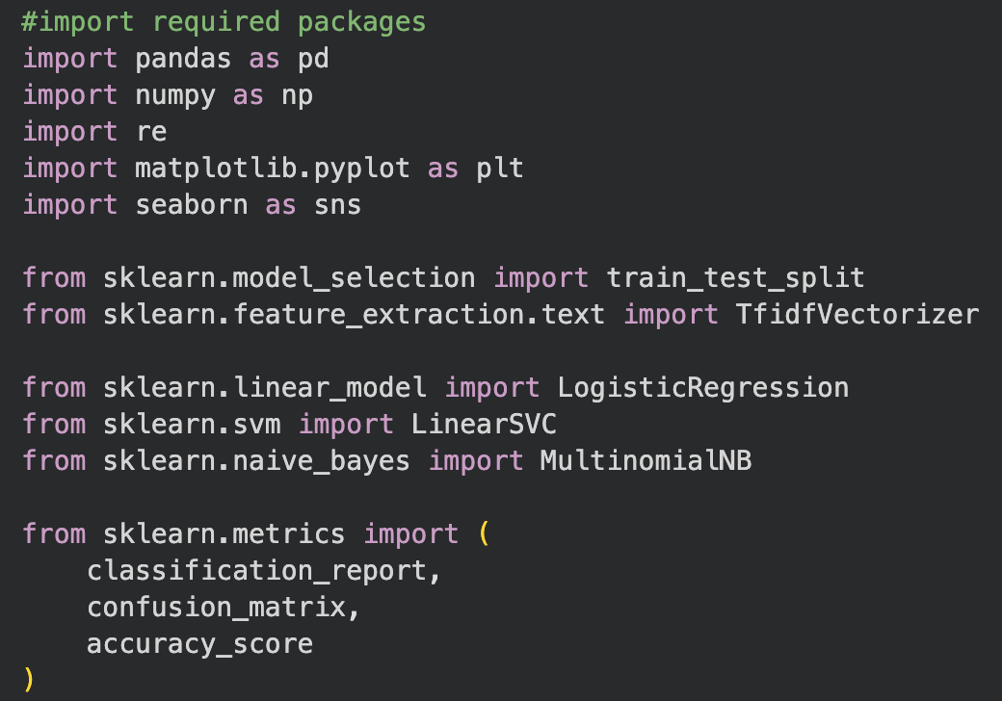
Appendix 2 Python code to import dataset
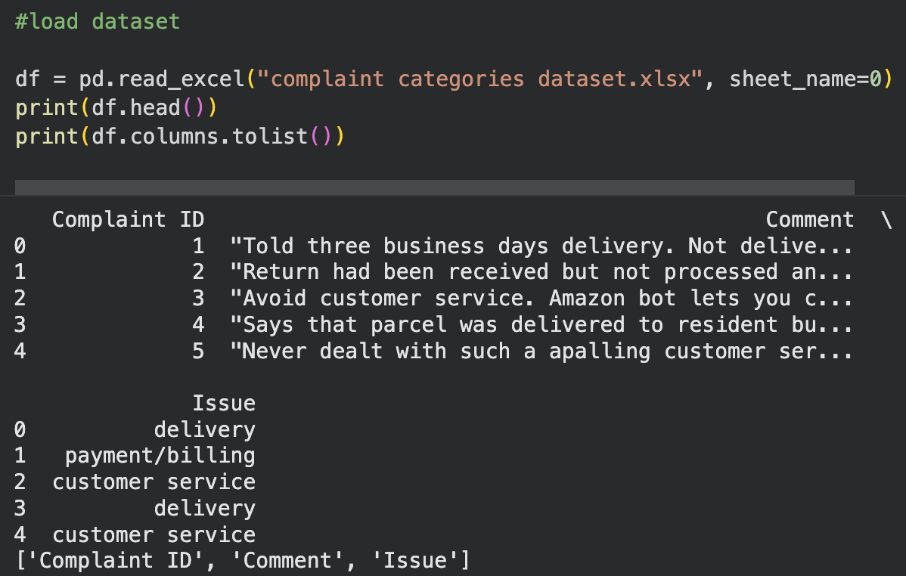
Appendix 3 Python code to clean labels and normalise categories
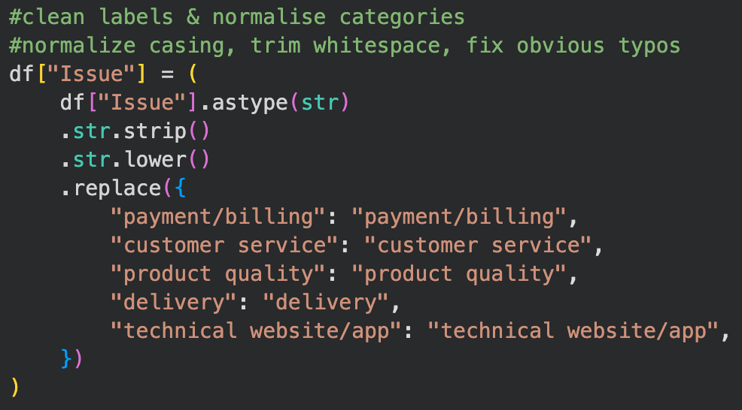
Appendix 4 Python code to convert text labels to numeric labels
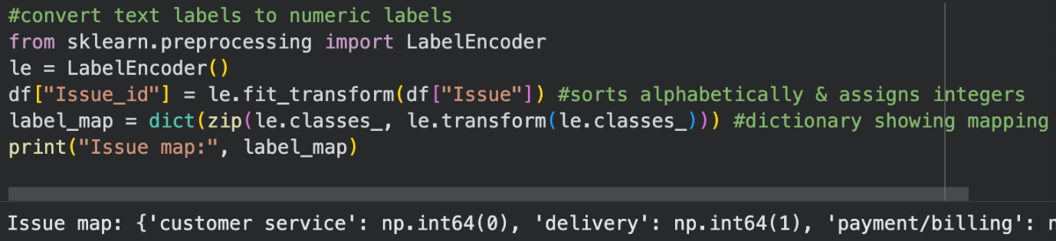
Appendix 5 Python code to normalise and clean text
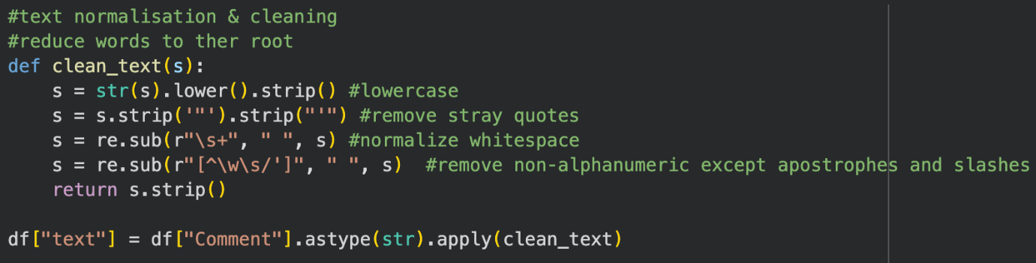

Appendix 6 Python code to handle common typos
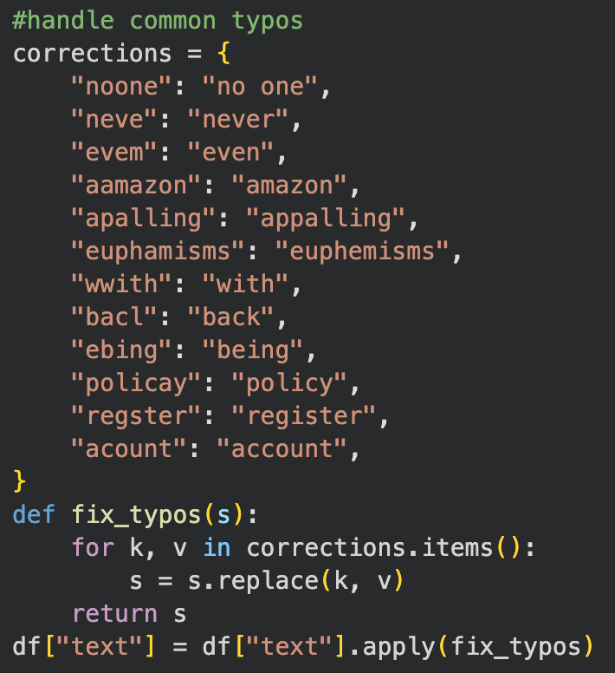
Appendix 7 Python code to check class distribution
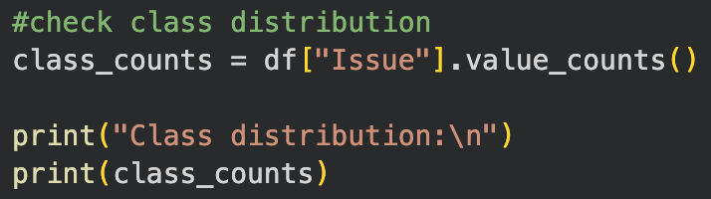
Appendix 8 Python code to split data into train and test sets
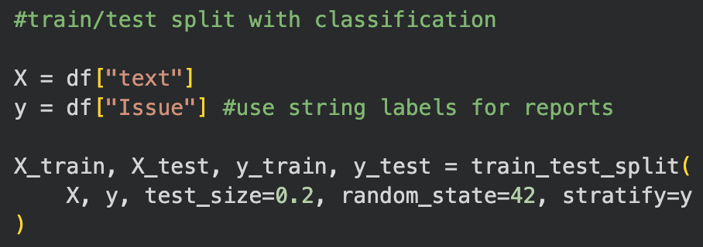
Appendix 9 Python code to convert text into TF-IDF vectors
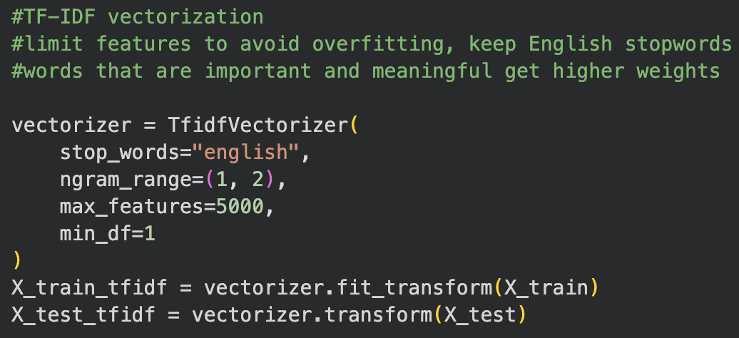
Appendix 10 Python code to save artifacts for reuse
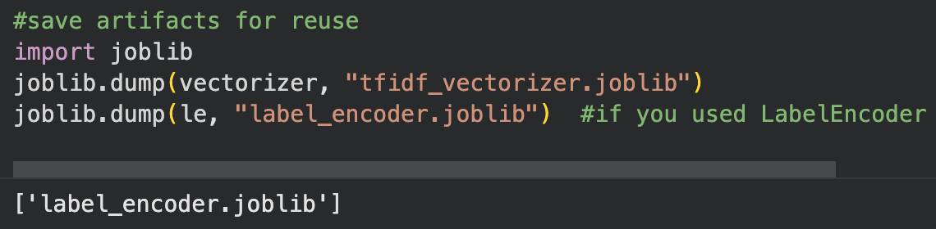
Appendix 11 Python code to train machine learning models
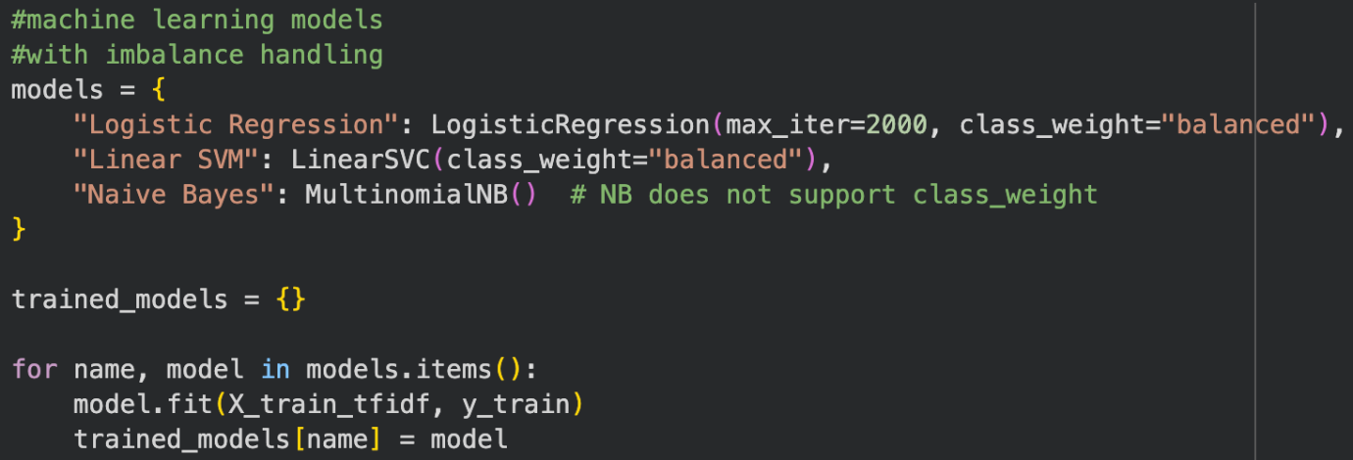

Appendix 12 Python code to evaluate model accuracy
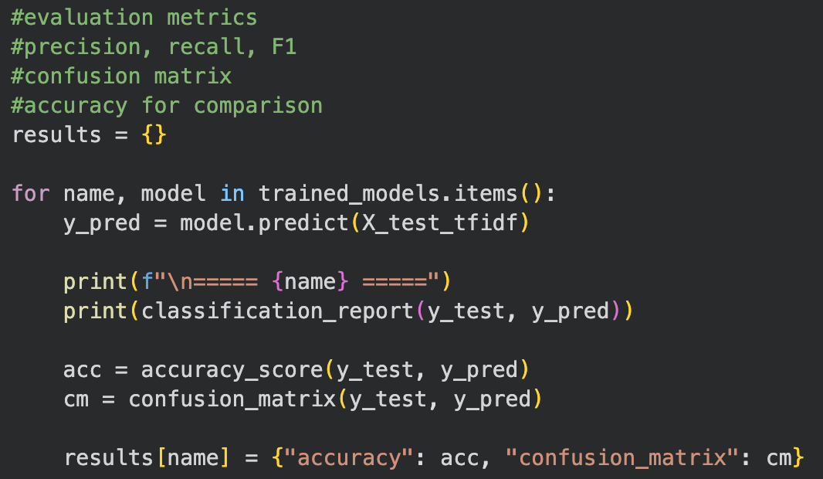
Appendix 13 Python code to create bar chart of accuracy comparison
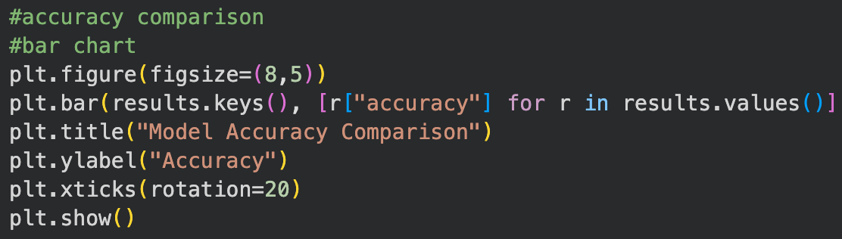
Appendix 14 Python code to create heatmap of confusion matrix
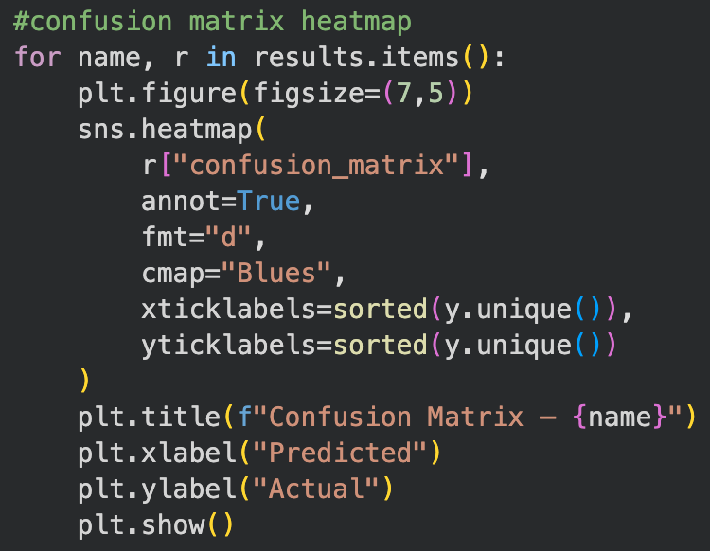
Appendix 15 Python code to create prediction function
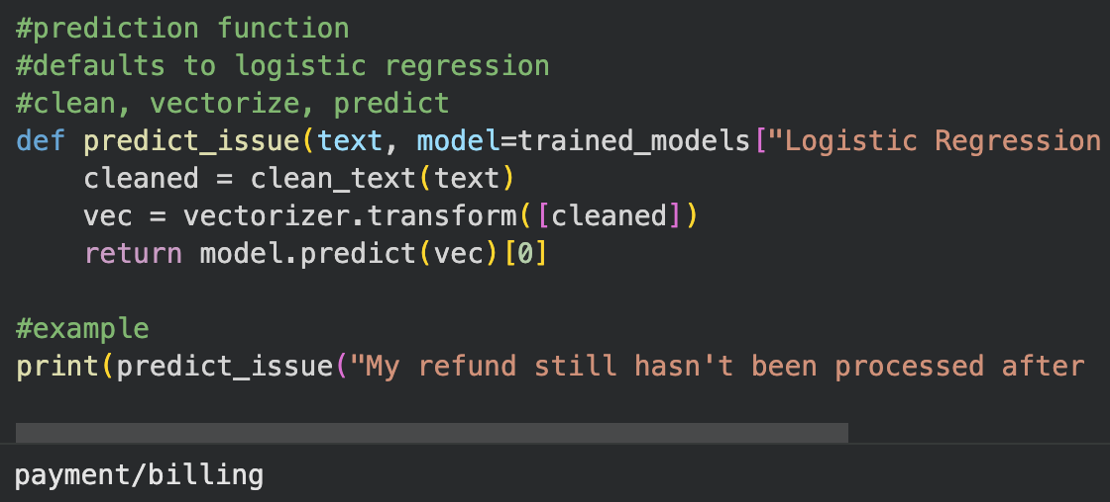
Appendix 16 Python code to save the model
